**Electronic Assignment Cover sheet**

Please fill out and attach as the first page of Assignment.

Student (s) Number as per your student card:

1725266 Peter Coker

Course Title: Higher Diploma in Science in Computing (Software Development Stream)

Lecturer Name: Clive Gargan

Module/Subject Title: Database Design & Development

Assignment Title: Technical Document

No of Words: 953

**Introduction**

The Database Design used follows a logical data model to build a new database management system for your Financial Services at BankCorp Ltd. This Database Design was designed to the exact specifications your company requested. It is also worth to mention that only the database was developed as agreed upon. However, another agreement can be discussed for any data migration tasks your company wants to take care off in any future project.

**Purpose**

The purpose of this Database Design was made to ensure that the design and develop of your new database meets the requirements that your company offers in wealth management and investment services to your personal and corporate clients at BankCorp Ltd. This document will describe how your new database addresses the issues with storing data by creating a new single database to merge all your data into a single source. The data model used also meets 3NF (Third Normal Form) requirements.

1. **Scope of the document.**
   1. This Database management system (DBMS) comprises of many different definitions for your new database objects that are put together by mapping different entities tables to develop, attributes to the column, unique identifiers to unique keys and relationships to a foreign key to develop a new single database for a Financial Services company of Bank Corp Ltd. That offers Wealth Management and Investment Services to your Personal and Corporate clients (Hoffer, Venkataraman and Topi, 2016, 47).
   2. A single database consolidated all the Wealth Management and Investment Services to Personal and Corporate clients of your company into a single source of reference data. This new database only includes one table to store each type of details of Accounts, Securities and Associations as discussed in the agreement. A soft delete method was used as your company requested instead of hard delete when removing reference data of each type of details of Accounts, Securities, and Associations as requested.
   3. The relevant benefit of only having a single database and a single source to store to each types of details of Accounts, Securities and Associations will allow your company to cut back on the cost of maintenance of having different databases and better simplify your tables opposed to having different tables to store each type of details of Accounts, Securities, and Associations. By using the logical model, the database was built with the specific information gathered from your business requirements that was agree upon (Gargan, 2017).
   4. There are many conditions to consider when looking any security risks with this database such as access to the server level with either using Windows or SQL Server (Gargan, 2017). Another concern is the lack of IT staff to perform regular backups of the new database (Gargan, 2017).
2. **Technical Design to include:**

**a. ER Diagram**

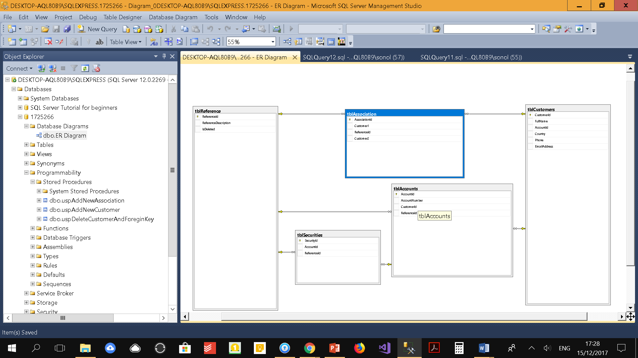

**b. Physical Model in Third Normal Form (3NF)**

**Customer Table**

|  |  |  |  |  |
| --- | --- | --- | --- | --- |
| **CustomerId** | **FullName** | **Country** | **Phone** | **EmailAddress** |
| 1 | Maurice Barrus | USA | 775550195 | MauriceBarrus@gmail.com |
| 2 | Shandra Carrasco | France | 775550188 | ShandraCarrasco@hotmail.com |
| 3 | Valerie Kalis | Sweden | 775550194 | ValerieKalis@hotmail.com |
| 4 | Jong Gundersen | Nigeria | 775550117 | JongGundersen@gmail.com |
| 5 | Hope Griffieth | Ireland | 775550126 | HopeGriffieth@yahoo.com |
| 6 | Joseph Hines | China | 2025550134 | JosephHines@teleworm.us |
| 7 | Aileen Corchado | Japan | 2025550156 | AileenCorchado@armyspy.com |
| 8 | Brandi Purkey | Spain | 2025550179 | BrandiPurkey@teleworm.us |
| 9 | Shirley Watkins | Italy | 2025550189 | ShirleyWatkins@rhyta.com |
| 10 | Jack Nelson | Russia | 2025550171 | JackNelson@dayrep.com |

**Primary Key: CustomerId ∞ (CustomerId ∞ → 1 AccountId)**

**Account Table**

|  |
| --- |
| **AccountId** |
| 1 |
| 2 |
| 3 |
| 4 |
| 5 |
| 6 |
| 7 |
| 8 |
| 9 |
| 10 |

**Primary Key: AccountId 1 (AccountId 1 ← ∞ CustomerId)**

**c. Data Dictionary**

Table Description;

Customers Table

* Six columns - CustomerId, FullName, AccountId, Country, Phone, EmailAddress
* Primary Key - CustomerId
* Foreign Key - AccountId
* No Columns allow Nulls
* 10 Rows of data insert into each column

Accounts Table

* Four columns - AccountId, AccountNumber, CustomerId, ReferenceId
* Primary Key - AccountId
* Foreign Key - CustomerId
* Foreign Key - ReferenceId
* No Columns allow Nulls
* 10 Rows of data inserted into each column

Securities Table

* Three columns - SecurityId, AccountId, ReferenceId
* Primary Key - SecurityId
* Foreign Key - AccountId
* Foreign Key - ReferenceId
* No Columns allow Nulls
* 10 Rows of data inserted into each column

Association Table

* Four columns - AssociationId, Customer1, ReferenceId, Customer2
* Primary Key - AssociationId
* Foreign Key - Customer1
* Foreign Key - ReferenceId
* Foreign Key - Customer2
* Unique constraint between Customer1 and ReferenceId column
* No Columns allow Nulls
* 10 Rows of data inserted into each column

Reference Table

* Three columns - ReferenceId, ReferenceDescription, IsDeleted
* Primary Key - ReferenceId
* No Columns allow Nulls
* 22 Rows of data inserted that stores each types of details of Accounts, Securities, and Associations

Table Relationships;

* Customers Table has a one-to-many relationship with Accounts Table
* Customers Table has a many-to-many relationship with Association Table
* Accounts Table has a one-to-many relationship with Securities Table
* Account Table has a one-to-many relationship with Reference Table
* Association Table has a one-to-many relationship with Reference Table
* Securities Table has a one-to-many relationship with Reference Table

**d. Technology used**

* Microsoft SQL Server Management Studio 2014 Express

1. **Testing.**

* Each View was tested to ensure that it runs.
* Each Stored Procedure was checked to ensure that it runs
* The reference data table was verified to ensure that a "Soft delete" was done when removing data.

1. **Reflection on Learnings.**
   1. Learning how to create a unique constraint in the Association table to create the unique association between a customer another customer.
   2. Several mistakes were made in creating a new Customer and Association. However, the task was split into two tasks. To simplify the process, by creating a new stored procedure to create a new Customer and Association. One stored procedure was only created to create new Customer to the Customers Table. While another stored procedures was created to add new Association to the Association Table.
   3. Creating the ability to delete a customer and foreign key records associated with this Customer via a Parameterized Stored Procedure was another challenging task. It took many tries and errors to conclude with a solution that meant creating a series of Data manipulation language commands to delete a customer and foreign key records associated with the Customer.
   4. One other challenging task was creating a SQL View which returned the association details. After several mistakes that finally led to a solution to create an Inner Join statements and create the SQL View.
2. **References**
   * Hoffer, J., Venkataraman, R. and Topi, H. (2016). Modern database management. 12th ed. Essex: Pearson Education Limited.
   * Gargan, C. (2017). Conceptual, Logical and Physical Model.
   * Gargan, C. (2017). Tutorial - SQL Server Security
   * Gargan, C. (2017). Server Level Roles File